EXPERIMENT NO:25

Design DFA using simulator to accept the string start with a or b over the set {a,b}

AIM: To design DFA using simulator to accept the string start with a or b over the set {a,b}

INPUT:

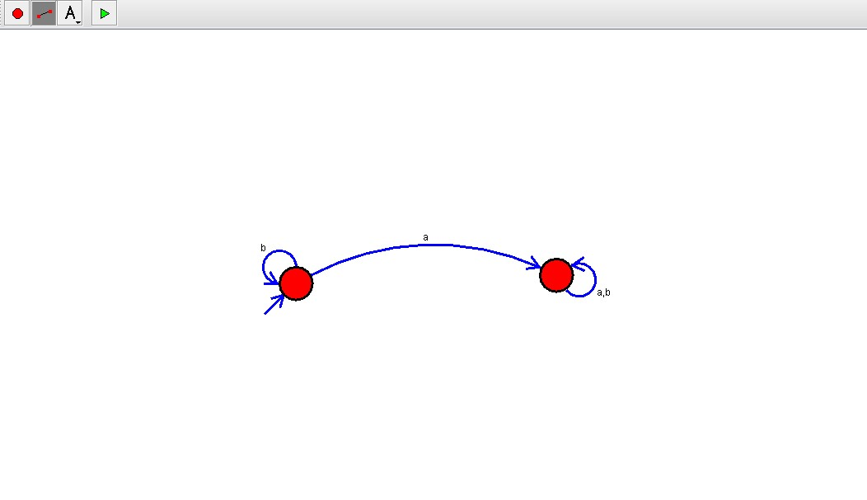

OUTPUT:

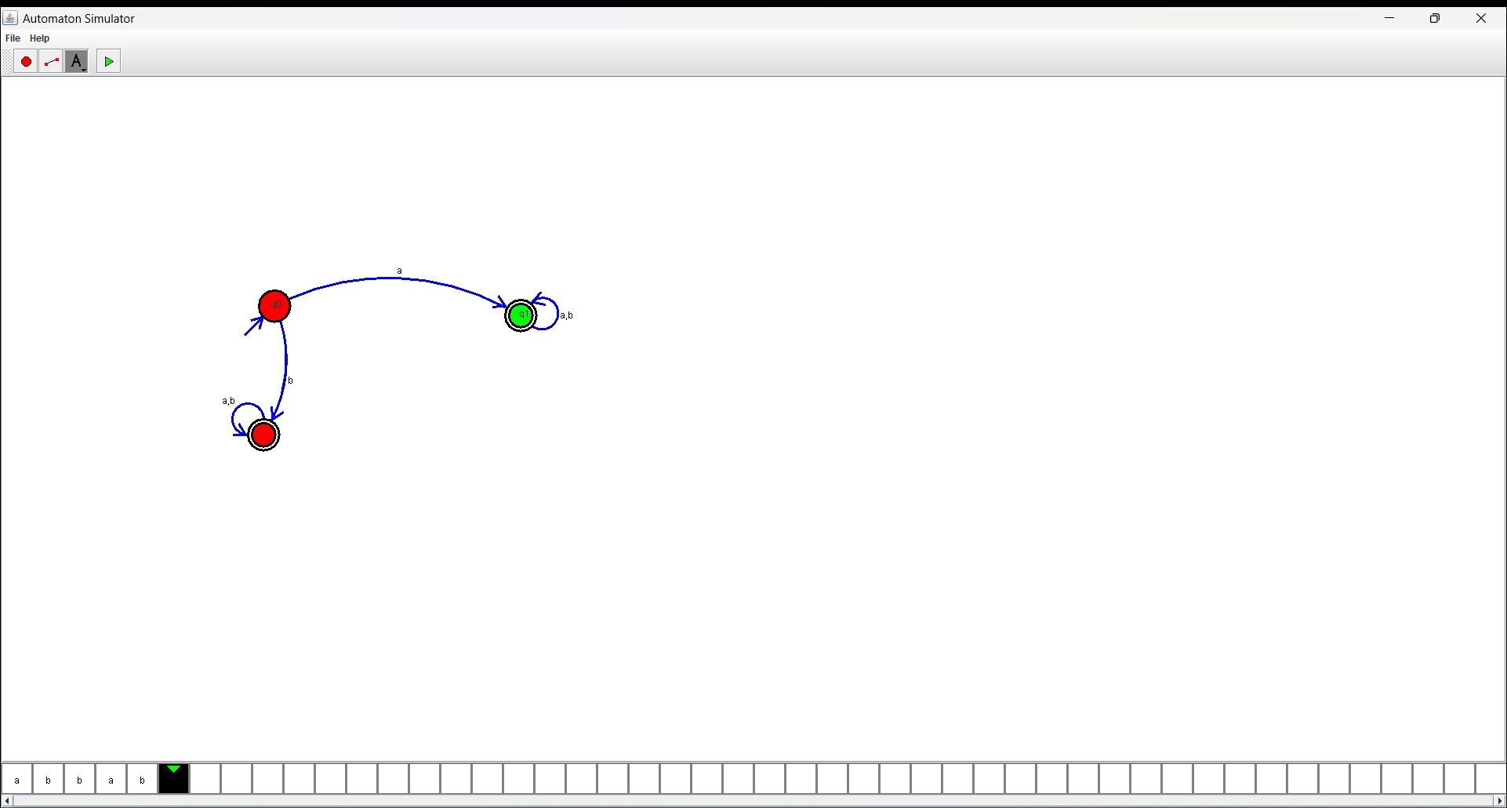

RESULT:

The program executed successfully and got output.